**DSA LAB – 5**

**Name:** Etcherla Sai Manoj **Mis. No:** 112015044 **Branch:** CSE

**Question 1:**

**Code:**

#include<iostream>

#include<cstring>

using namespace std;

struct employee

{

int emp_id;

string emp_name;

struct employee *next;

};

class program{

employee *head = NULL, *temp = NULL, *sample = NULL, *head1 = NULL, *head2 = NULL, *temp1 = NULL, *temp2 = NULL;

int id, counter, i;

string name;

public:

employee *create();

void insert();

void remove();

void list_display();

void count();

void reverse();

void rev(employee *p);

void concat();

};

employee *program::create(){

employee *p = new(struct employee);

cout << "Enter I.D. : ";

cin >> id;

cout << "Enter name : ";

cin >> name;

p->emp_id = id;

p->emp_name = name;

p->next = NULL;

return p;

}

void program::insert(){

employee *p = create();

if(head == NULL){

head = p;

}

else{

temp = head;

while(temp->next != NULL){

temp = temp->next;

}

temp->next = p;

}

}

void program::remove(){

int sid, flag = 0;

cout << "Enter I.D. of employee whose data you want to delete : ";

cin >> sid;

temp = head;

while(temp->next != NULL){

if(temp->emp_id == sid){

sample->next = temp->next;

delete(temp);

flag = 1;

}

sample = temp;

temp = temp->next;

}

if(flag == 0){

cout << "Sorry user not found!!! Check again!!!\n";

}

}

void program::list_display(){

if(head == NULL){

cout << "List is empty\n";

}

else{

temp = head;

cout <<"------------------\n";

cout << "I.D.No \t Name\n";

cout <<"------------------\n";

while(temp->next != NULL){

cout << temp->emp_id << "\t" << temp->emp_name << "\n";

temp = temp->next;

}

cout << temp->emp_id << "\t" << temp->emp_name << "\n";

}

}

void program::count(){

temp = head;

counter = 0;

while(temp->next != NULL){

temp = temp->next;

counter++;

}

counter++;

cout << "Total number of employees : " << counter << endl;

}

void program::reverse(){

cout <<"------------------\n";

cout << "I.D.No \t Name\n";

cout <<"------------------\n";

rev(head);

}

void program::rev(employee *temp){

if(temp == NULL){

return;

}

else{

rev(temp->next);

}

cout << temp->emp_id << "\t" << temp->emp_name << "\n";

}

void program::concat(){

int k,j;

cout<<"Enter no. of members in list1 : ";

cin>>k;

head=NULL;

for(i=0;i<k;i++){

insert();

head1=head;

}

head=NULL;

cout<<"Enter no. of members in list2 : ";

cin>>j;

for(i=0;i<j;i++){

insert();

head2=head;

}

head=NULL;

temp1=head1;

while(temp1->next!=NULL){

temp1=temp1->next;

}

temp1->next=head2;

temp2=head1;

cout << "---------------------\n";

cout << "I.D.No.\t\tNAME\n";

cout << "---------------------\n";

while(temp2->next!=NULL){

cout<<"\n"<<temp2->emp_id<<"\t\t"<<temp2->emp_name;

temp2=temp2->next;

}

cout<<"\n"<<temp2->emp_id<<"\t\t"<<temp2->emp_name;

cout << "\n";

}

int main(){

program p;

int choice;

cout << "***********Menu Options***********" << endl;

cout << "1. COUNT number of employees" << endl;

cout << "2. DISPLAY the list" << endl;

cout << "3. INSERT a node into the list" << endl;

cout << "4. DELETE a node from the list" << endl;

cout << "5. DISPALY list in reverse order" << endl;

cout << "6. CONCATENATE two lists" << endl;

cout << "7. EXIT" << endl;

cout << "----------------------------------" << endl;

cout << "Enter your choice : ";

cin >> choice;

do{

switch (choice)

{

case 1:

p.count();

break;

case 2:

p.list_display();

break;

case 3:

p.insert();

break;

case 4:

p.remove();

break;

case 5:

p.reverse();

break;

case 6:

p.concat();

break;

case 7:

return 0;

break;

default:

cout << "Enter a valid option !!!" << endl;

break;

}

cout << "\nEnter your choice : ";

cin >> choice;

}while(choice != 7);

return 0;

}

**Input & Output:**

**Counting number of employees:**

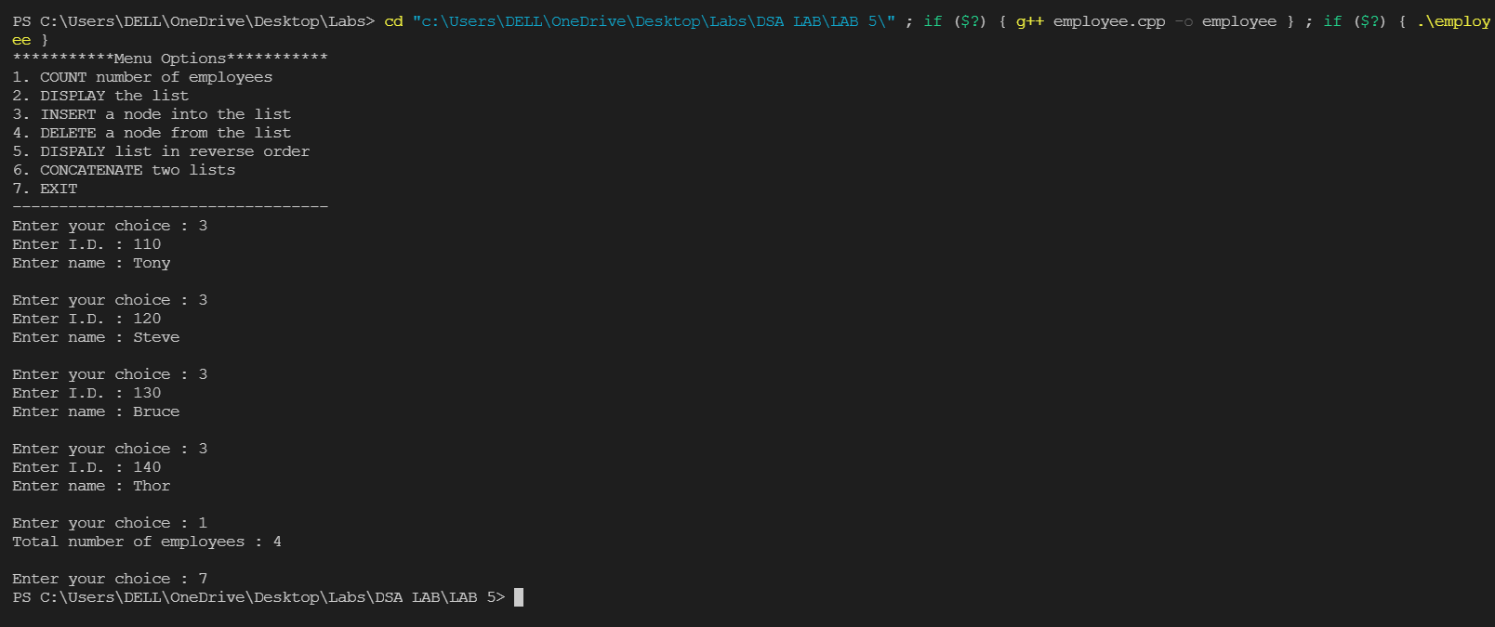

**Displaying the list:**

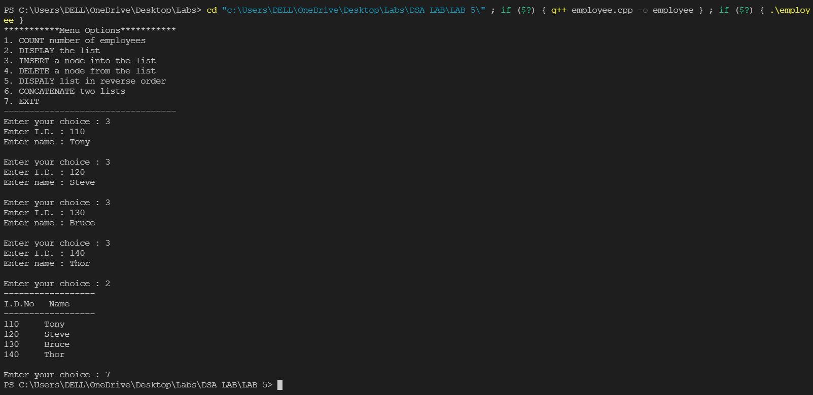

**Deleting a node:**

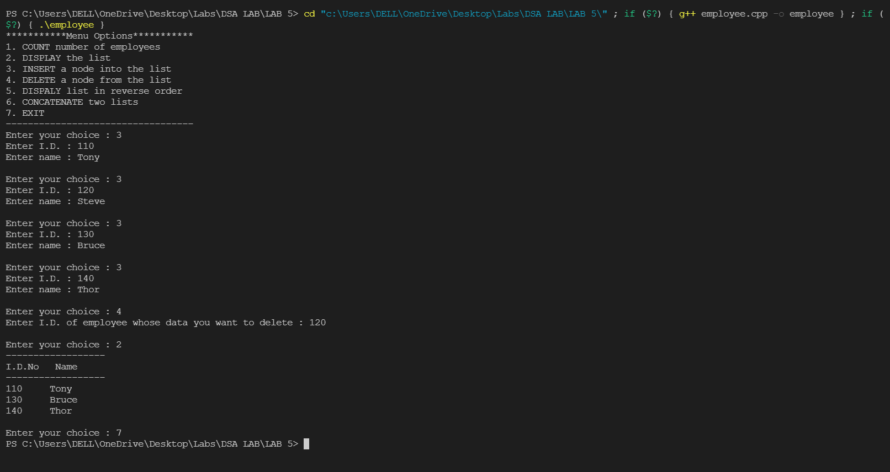

**Display list in reverse order:**

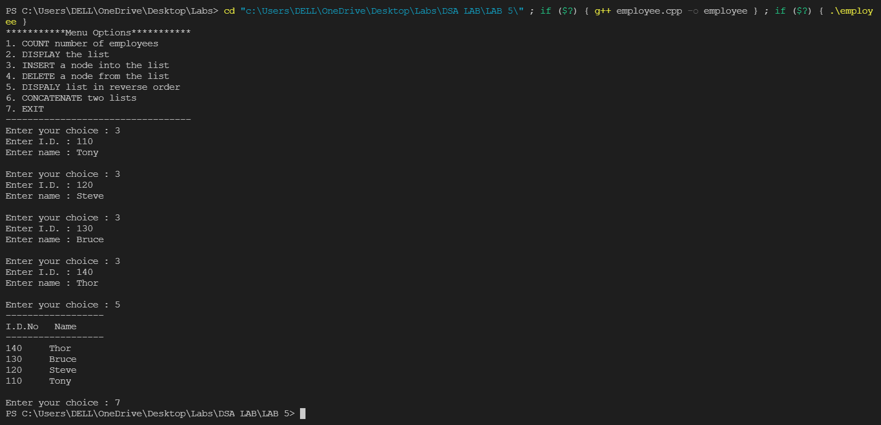

**Concatenation of two lists:**

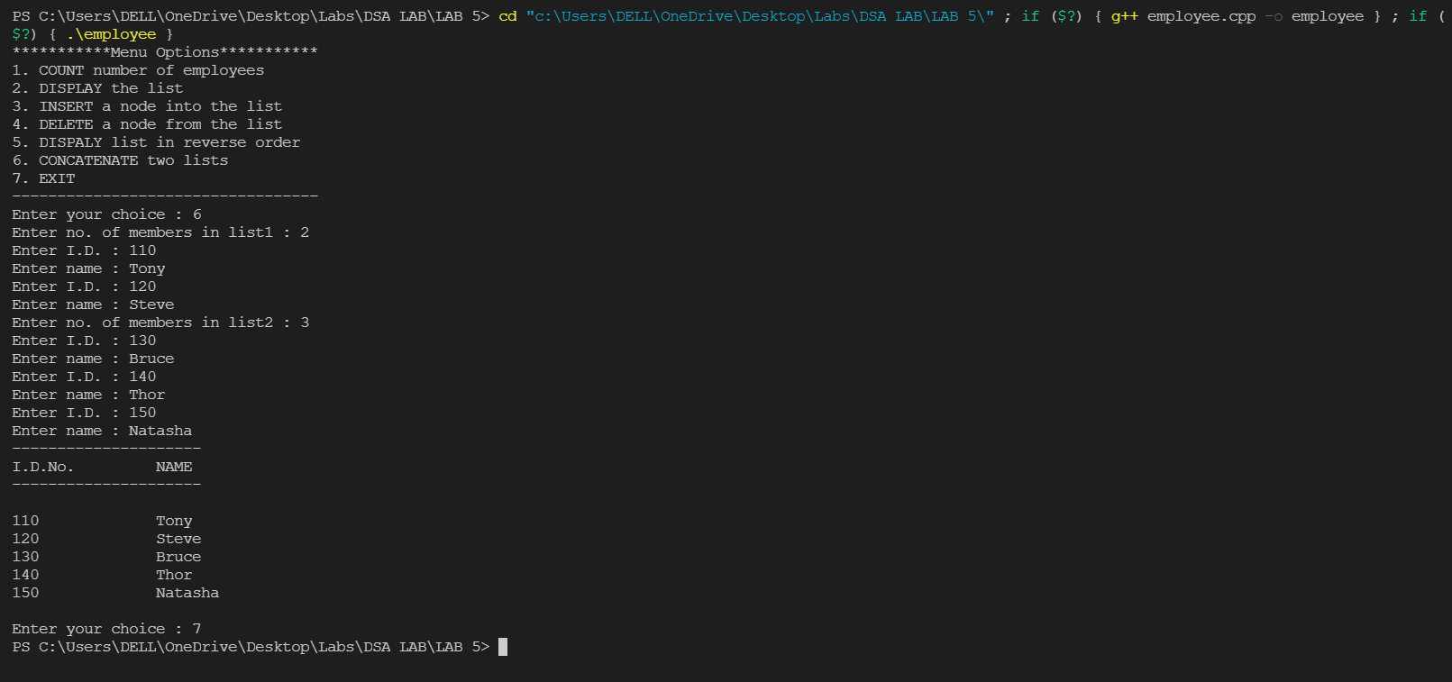

**Question 2:**

**Code:**

#include<iostream>

using namespace std;

struct node

{ int x;

node *next,*prev;

};

class binary

{ node *head=NULL,*temp=NULL, *head1=NULL,*temp1=NULL, *head2=NULL,*temp2=NULL,*temp3=NULL,*head3=NULL;

int c,i;

public:

node *create();

void insert();

void binary1();

void binary2();

void add();

void com();

void comp();

void display();

};

node *binary::create()

{ node *p=new(struct node);

cout<<"Enter binary digit : ";

cin>>c;

p->x=c;

p->next=NULL;

p->prev=NULL;

return p;

}

void binary::insert()

{

node *p=create();

if(head==NULL)

{ head=p;

}

else

{ temp=head;

while(temp->next!=NULL)

{ temp=temp->next; }

temp->next=p;

p->prev=temp;

}

}

void binary:: binary1(){

int a;

cout<<"Enter the no. of bits : ";

cin>>a;

cout << "---Enter binary number digit wise---\n";

head=NULL;

for(i=0;i<a;i++){

insert();

}

head1=head;

display();

head=NULL;

temp1=head1;

}

void binary:: binary2(){

int a;

cout<<"Enter the no. of bits : ";

cin>>a;

cout << "---Enter binary number digit wise---\n";

head=NULL;

for(i=0;i<a;i++){

insert();

}

head2=head;

display();

head=NULL;

}

void binary::add(){

int carry=0;

temp1=head1;

cout << "Addition of two binary numbers : ";

while(temp1->next!=NULL){

temp1=temp1->next;

}

temp2=head2;

while(temp2->next!=NULL){

temp2=temp2->next;

}

while(temp1!=NULL)

{

node *p=new(struct node);

p->next=NULL;

p->prev=NULL;

if(temp1->x==0&&temp2->x==0){

p->x=0+carry; carry=0;

}

if(temp1->x==0&&temp2->x==1)

{

if(carry==0){

p->x=1;carry=0;

}

else{

p->x=0;

carry=1;

}

}

if(temp1->x==1&&temp2->x==0)

{

if(carry==0){

p->x=1;carry=0;

}

else{

p->x=0; carry=1;

}

}

if(temp1->x==1&&temp2->x==1)

{

if(carry==0){

p->x=0; carry=1;

}

else{

p->x=1; carry=1;

}

}

if(temp3==NULL){

temp3=p;

}

else

{

p->next=temp3;

temp3=p;

}

temp1=temp1->prev;

temp2=temp2->prev;

}

node *p=new(struct node);

p->x=carry;

p->next=NULL;

p->prev=NULL;

if(temp3==NULL)

{ temp3=p; }

else

{

p->next=temp3;

temp3=p;

}

head3=temp3;

temp3=head3;

cout<<"\n";

while(temp3->next!=NULL){

cout<<" "<<temp3->x;;

temp3=temp3->next;

}

cout<<" "<<temp3->x<<"\n";

}

void binary::com(){

while(temp1!=NULL)

{

node *p=new(struct node);

p->next=NULL;

p->prev=NULL;

if(temp1->x==0)

p->x=1;

else

p->x=0;

if(head==NULL)

{ head=p;

}

else

{ temp=head;

while(temp->next!=NULL)

{ temp=temp->next; }

temp->next=p;

p->prev=temp;

}

temp1=temp1->next;

} cout<<"\n1's compliment of binary no. : ";

display();

int f=0;

while(temp!=NULL)

{ if(temp->x==1)

{ temp->x=0; }

else

{ temp->x=1; f=1;

break;

} temp=temp->prev;

}

if(f==0)

{ node *p=new(struct node);

p->next=NULL;

p->prev=NULL;

p->x=1;

temp=head;

head=p;

head->next=temp;

temp->prev=head;

}

cout<<"\n2's compliment of binary no. : ";

display();

}

void binary::comp()

{

cout<<"\nFor first binary no.";

temp1=head1;

com();

head=NULL;

cout<<"\nFor second binary no. ";

temp1=head2;

com();

}

void binary::display(){

temp=head; cout<<"\n";

while(temp->next!=NULL){

cout<<" "<<temp->x;;

temp=temp->next;

}

cout<<" "<<temp->x<<"\n";

}

int main()

{ binary b;

int choice;

cout << "\n***********Menu Options***********";

cout << "\n 1. Insert binary1";

cout << "\n 2. Insert binary 2";

cout << "\n 3. Add binary no.s";

cout << "\n 4. 1's and 2's compliment of binary no.";

cout << "\n 5. Exit";

cout << "\n----------------------------------" << endl;

cout << "\nEnter your choice : ";

cin>>choice;

do{

switch(choice)

{ case 1:

b.binary1();

break;

case 2:

b.binary2();

break;

case 3:

b.add();

break;

case 4:

b.comp();

break;

case 5:

return 0;

break;

default:

cout<<"Enter valid Choice";

break;

}

cout << "\nEnter your choice : ";

cin>>choice;

}while(choice != 5);

return 0;

}

**Input & Output:**

**Addition:**

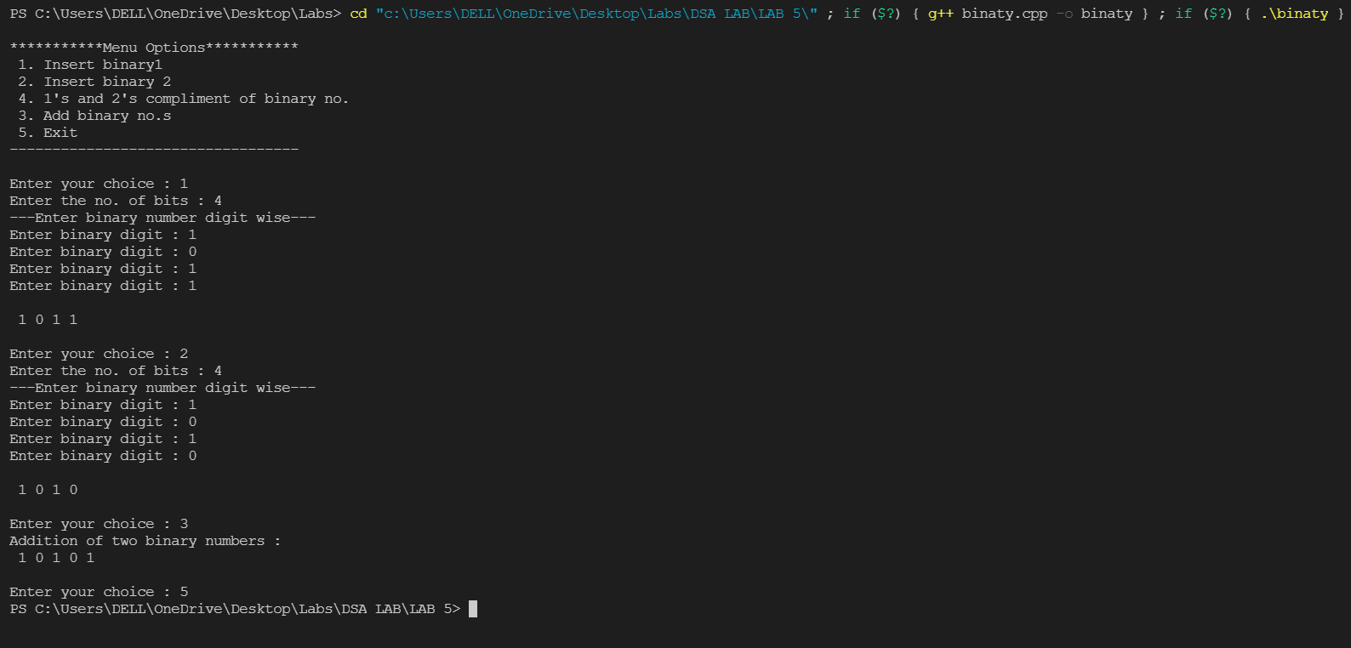

**1’s and 2’s Complement:**

